Supplementary Materials
for [{Cd₁₂(dpa)₆(pya)₆}(pya)₆(dpe)₃]_{n}

Synthesis of 1.

Fig. S1. A view of one-dimensional pillar in 1 along a axis with dpe omitted

for clarity.

Fig. S2The thermogravimetric analysis (TGA) diagram

Fig. S3 The differential thermal analysis (DTA) diagram
Fig. S4. The X-ray power diffraction (XRPD) pattern (a) taken at room
temperature (b) after heating at 220 ºC for 2h (c)after heating
at 300 ºC for 2h.

Synthesis of 1: A mixture of diphenic acid (0.12 g, 0.5 mmol), 1,2-di(4-pyridyl)ethylene (0.09 g, 0.5 mmol), Cd(NO₃)₂·4H₂O (0.15 g, 0.5 mmol), NaOH (0.03 g, 0.75 mmol) and H₂O (14 mL) in a molar ratio of about 1:1:1:1.5:1500 was placed in a Parr Teflon-lined stainless steel vessel and heated to 180 ºC for 72 h, then cooled the reaction system to room temperature during 5 hours. A larger amount of colorless crystals were obtained and collected by filtration, washed with water and dried in air, yield 0.16 g (80%, based on Cd(NO₃)₂·4H₂O). Elementary analysis: calcd. for C₃₂H₂₁Cd₂N₃O₈: C, 48.02; H, 2.62; N, 5.25%, found: C, 48.07; H, 2.67; N, 5.34%. IR (KBr pellet): 3418(w), 3061(w), 1618(s), 1601(s), 1579(s), 1547(s), 1504(w), 1439(m), 1392(s), 1375(s), 1358(s), 1147(w), 1016(w), 860(w), 758(m), 715(m), 683(m), 552(w) cm⁻¹.

Fig. S1. A view of one-dimensional pillar in 1 along a axis with dpe omitted
for clarity.

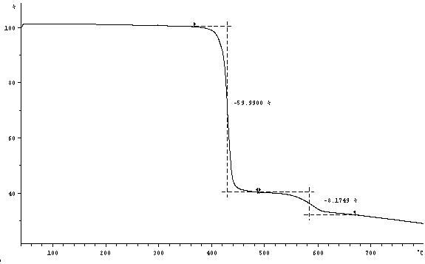

Fig. S2. TGA diagram

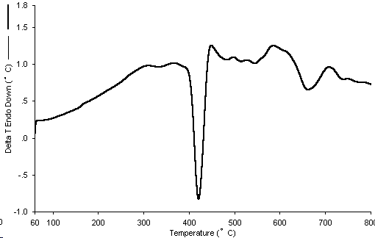

Fig. S3. DTA diagram

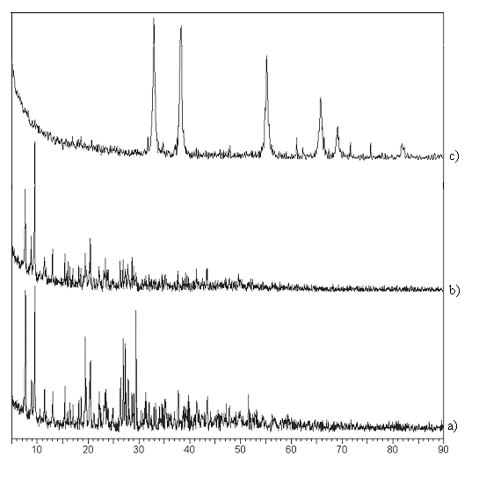

Fig. S4. The X-ray power diffraction (XRPD) pattern (a) taken at room
temperature (b) after heating at 280 ºC for 2h (c)after heating
at 300 ºC for 2h.

